Private Attorney Request for Litigation Expenses
Missouri State Public Defender
(Please print or type)

Send this form and completed MSPD indigence application, signed by the defendant to:
MSPD Case Contracting at Case.Contracting@mspd.mo.gov or Fax #573-777-9975

Date __________________ 20_____

Name ____________________________Firm Name_________________________ MoBar #

Office Address __________________________________City __________________Zip Code

Office Phone ______________________Cell Phone ______________________ Fax _____________________

E-Mail Address

Date of appointment / entry of appearance:

Attorney Status: Pro Bono Appointed by Court Retained by defendant

Defendant Name:

Circuit & County of Charge: _______________________________________Cause #:

Charge(s):

Arraignment Date: _______________________ Next Court Date:

Case Status:

If retained by defendant, complete the following:

Fee agreement: Copy attached Oral agreement [please describe below]

Compensation received in this case:

Compensation received from or on behalf of the client within the previous 24 months not included in the previous question. Please provide circumstances and purpose, as well as the amount received.

List amount and purpose of any litigation expenses already covered out of received fees.

Do you agree to apply any future compensation received on behalf of this client to the expense costs in this case or to any lien for MSPD costs in this case?

If the above fee agreement is not representative of what you have been paid, please explain:

I hereby certify that, to the best of my information and belief, the above information is correct.

Attorney Signature:____________________________________________________ Date: ______________________

NOTE: MSPD will only cover litigation expenses for an indigent defendant with retained counsel where the attorney’s fee, minus litigation expenses already covered, does not exceed the contract fee paid by MSPD to private attorneys for comparable cases. Please check the attached MSPD contract fee schedule before submitting a request for litigation expenses.

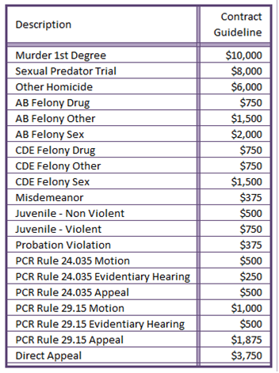

PLEASE NOTE: Once a case is approved as eligible for litigation expenses, requests for individual expenditures will be treated exactly as MSPD requests for similar expenses from public defenders. Each anticipated expense must be requested and approved in advance of being incurred. The procedure for this will be provided if the case is deemed eligible for litigation expenses.

Only expenses deemed reasonable and necessary for effective representation will be approved. By way of example, the following information is required when asking for specific litigation expenses and may be submitted in narrative form by email to Case.Contracting@mspd.mo.gov:

Deposition(s) Who is to be deposed, why they are material to the case, and why the information sought cannot effectively be obtained through informal interview or other means.

Expert(s) The type of expert sought, what in the case leads you to believe such an expert is necessary and material to the case, the hourly rate and total cost anticipated, as well as what is included in that total cost (i.e. evaluation, record review, travel, testimony, etc.) Note: Expert expenses (lodging, travel, meals, etc.) will be reimbursed at the same rate as public defender employee expenses.

Transcript(s) & Records A description of what is being sought, why it is relevant and material to your case, and the anticipated cost.

Investigation A detailed description of the investigation required and why it is relevant and material to your case. If you have a private investigator in mind to do the work, please provide his/her name, contact information, hourly rate and estimated total cost of services.

